ITIS 6617 SYSTEM INTEGRATION

FINAL PROJECT

Saikumar kodumunja

USER GUIDE FOR

## Azure AI Vision "Image Analysis"

Version: 1.0

Final Draft

University of North Carolina, Charlotte 2023

Contents

1. Introduction ……………………………………………. 3
   1. Overview of Azure AI Vision, specifically the "Image Analysis"
   2. Key Features
   3. Accessibility
   4. Limitations
   5. Deployment and Availability
2. Getting Started with Azure AI Vision, specifically the "Image Analysis"

2.1. Access Points

2.2. Requirements

2.3. Using the Web Interface

2.4. Using an API tool

2.5. Alternative Testing with Swagger UI

3. Troubleshooting and Support

3.1. Identifying Common Issues

3.2. Troubleshooting Steps

3.3. Error Code Reference

3.4. Contacting Support

3.5. Best Practices for Efficient Support

3.6. Community and Resources

3.7. Service Level Agreements (SLAs)

3.8. Feedback Mechanisms

4. FAQs

1. Introduction

1.1 Overview of Azure AI Vision, specifically the "Image Analysis"

Azure Vision AI, a core component of Microsoft Azure's Cognitive Services, offers robust capabilities for image analysis. It encompasses functionalities such as object detection, facial recognition, text extraction, and more.

1.2 Key Features

The service simplifies complex tasks like extracting text from images, identifying objects and their positions, and analyzing facial expressions. Its capabilities are tailored to streamline various image analysis requirements seamlessly.

1.3 Accessibility

Azure Vision AI stands as an accessible artificial intelligence service, designed to seamlessly integrate into applications across diverse domains. Its user-friendly interface and extensive documentation facilitate easy adoption.

1.4 Limitations

While Azure Vision AI offers a comprehensive suite of image analysis tools, it may have limitations based on specific use cases or complex scenarios. Users should review documentation to understand these constraints thoroughly.

1.5 Deployment and Availability

This service is available within the Microsoft Azure ecosystem, ensuring wide availability for integration into applications. Deployment is supported across various platforms, enhancing its accessibility.

This comprehensive introduction outlines the essence of Azure's AI Vision services, specifically focusing on image analysis capabilities and its potential applications across industries.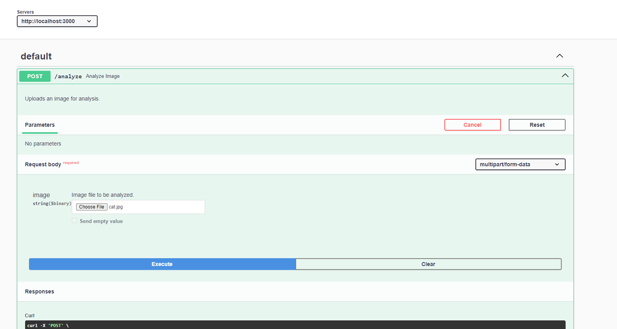

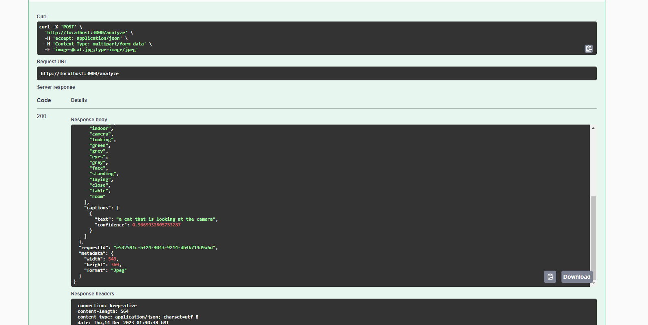

# 2. Getting Started with Azure AI Vision, specifically the "Image Analysis"

2.1 Access Points

To utilize our API for Azure Vision AI integration, access the API endpoint provided for image analysis. This endpoint serves as the entry point for uploading images and initiating the analysis process.

2.2 Requirements

No specific authentication or API keys are required to interact with this API. It's open for all users, simplifying the integration process.

2.3 Using the Web Interface

Users can interact with the API through various methods. The web interface allows for easy integration by directly sending POST requests to the API endpoint, providing the image data for analysis.

2.4 Using an API tool

For users seeking a more user-friendly approach or advanced testing, tools like Postman can streamline the process. Follow these steps to initiate the image analysis using Postman:

1. Download and install Postman.

2. Create a new request and set it to "POST".

3. Enter the API endpoint URL.

4. In the "Body" tab, select "form-data", add a key for the image, and attach the image file.

5. Send the POST request to begin the analysis process.

2.5 Alternative Testing with Swagger UI

If preferred, users can leverage Swagger UI for alternative testing. Swagger UI provides a dynamic and interactive interface, allowing users to interact with the API endpoints directly within the browser.

This comprehensive guide aims to facilitate a smooth integration process, providing users with multiple avenues to interact with the API and initiate image analysis using Azure Vision AI.

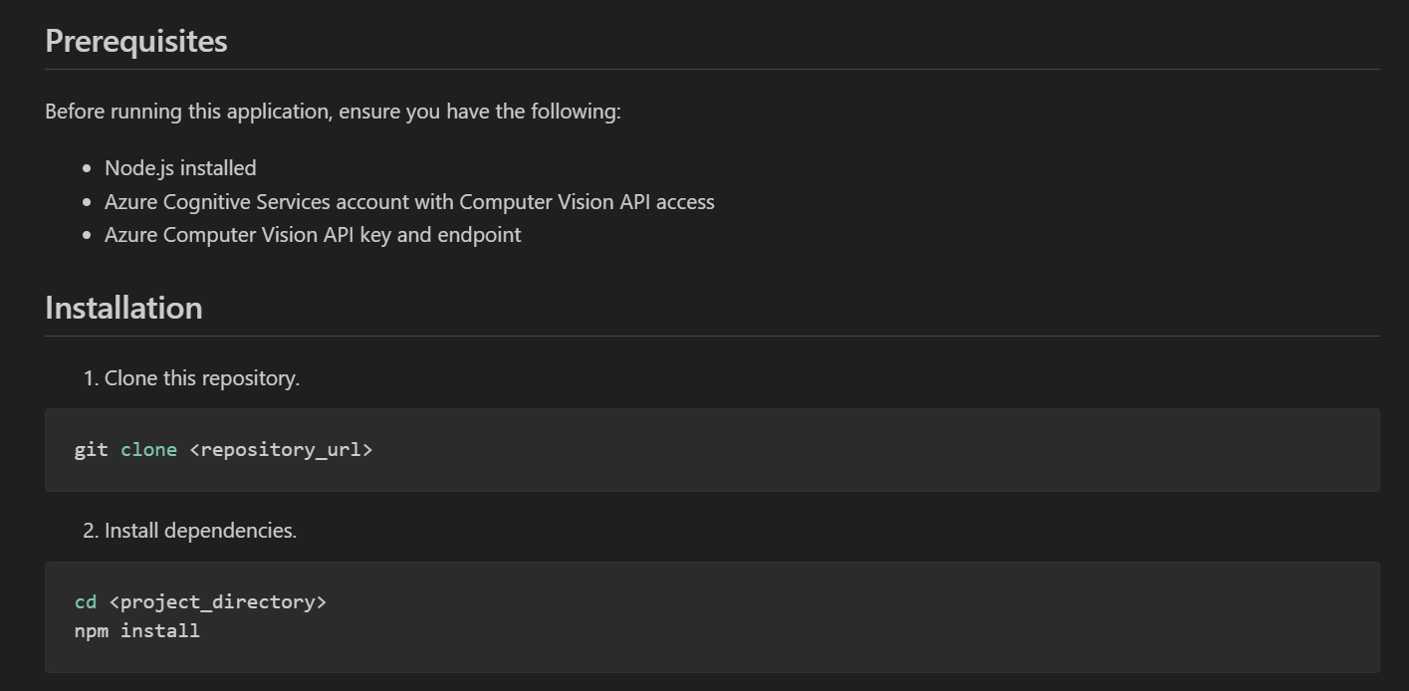

Certainly, here's the provided content structured into the specified sections:

# 3. Troubleshooting and Support

3.1 Identifying Common Issues

While utilizing our API for Azure Vision AI integration, users might encounter common issues that could affect the analysis process.

3.2 Troubleshooting Steps

Here are potential solutions to address common issues:

1. Image Analysis Failures

- Verify image format and Azure Vision AI service requirements.

- Check API endpoint URL configuration and accessibility.

- Review image data for potential errors.

2. Slow Response Times

- Assess API infrastructure performance for bottlenecks.

- Investigate network congestion causing delays in communication.

3. Rate Limiting

- Understand Azure's rate limit policies.

- Optimize application to stay within usage limits.

4. Unexpected Results

- Understand Azure Vision AI limitations and potential inaccuracies.

- Ensure image data quality aligns with analysis requirements.

- Consider post-processing or filtering results for accuracy improvement.

3.3 Error Code Reference

[This section can provide specific error codes and their meanings, aiding users in understanding encountered issues.]

3.4 Contacting Support

If issues persist or further assistance is needed, users can reach out to our support team for dedicated assistance.

3.5 Best Practices for Efficient Support

[This section can outline tips for users to receive effective and prompt support from the team.]

3.6 Community and Resources

[Include links or information about community forums, blogs, or additional resources where users can find help or engage with others using the API.]

3.7 Service Level Agreements (SLAs)

[Details about the service level agreements, including response times for support requests, etc.]

3.8 Feedback Mechanisms

[Instructions on how users can provide feedback about their experiences or encountered issues, helping improve the API's functionality.]

4. FAQs

Q1. What types of image analysis does Azure AI Vision support?

Azure AI Vision offers a wide array of analysis features, including image categorization, description generation, color extraction, object detection, and more. These functionalities enable comprehensive understanding and extraction of details from uploaded images.

Q2. Are there specific image formats or size limitations for analysis?

Azure AI Vision supports various image formats such as JPEG, PNG, BMP, and GIF among others. While there isn’t a strict size limitation, extremely large images might affect processing times. It's recommended to optimize image sizes for efficient analysis.

Q3. How accurate is the image analysis provided by Azure AI Vision?

The accuracy of image analysis depends on various factors, including the complexity of the image, quality of the input, and the specific analysis features used. Azure AI Vision strives for high accuracy but results may vary based on the input data.

Q4. Can Azure AI Vision analyze multiple objects/entities within a single image?

Yes, Azure AI Vision can detect and analyze multiple objects, scenes, or entities within a single image. It provides detailed information about different elements present, helping users understand the image content comprehensively.

Q5. Is there a limit to the number of image analysis requests allowed?

Azure AI Vision services often have usage limits based on subscription tiers. Users are encouraged to review the service plan for their account, which usually outlines the maximum number of analysis requests allowed within a certain timeframe.

Q6. How can I improve the accuracy of image analysis results?

To enhance accuracy, consider providing high-quality images with clear details, avoid overly compressed or distorted images, and utilize specific analysis features tailored to your needs. Fine-tuning parameters and utilizing multiple analysis methods can also improve accuracy.

Q7. Are there any privacy or security concerns regarding uploaded images for analysis?

Azure AI Vision takes privacy and security seriously. Uploaded images for analysis are processed securely and user data is handled following Microsoft's strict privacy policies. However, users should ensure they have necessary permissions for the images they upload.

Q8. Can Azure AI Vision be integrated with custom applications or platforms?

Yes, Azure AI Vision provides APIs and SDKs that allow seamless integration with custom applications or platforms. This enables developers to leverage the image analysis capabilities within their own software solutions.

Q9. What happens if an image analysis request fails or encounters an error?

If an image analysis request fails or encounters an error, Azure AI Vision usually provides detailed error messages or codes, allowing users to troubleshoot or report issues effectively. It’s recommended to check the error message and review input data for potential issues.

Q10. Is there a difference between real-time and batch image analysis?

Real-time image analysis refers to immediate processing of images upon upload or request, providing instant results. Batch analysis involves processing multiple images simultaneously, which might take longer but allows for analyzing larger datasets.

---